Template

“Know Your MP”

Software Development

Version: 1.0.0

2nd August, 2013

Team: Lunatics
Member name:
Deepak kumar Yadav

Revision History

Date | Description | Author | Comments
5th August, 2013 | Version 1.0 | Deepak Kumar Yadav | It’s a First Version and will  revise soon according to the  user’s requirments.

Document Approval

The following Requirements has been accepted and approved by the following:
Signature | Printed Name | Title | Date

Table of Contents

1. Introduction

1.1 Purpose

1.2 Scope

1.3 Definitions, Acronyms, and Abbreviations

1.4 References

1.5 Overview

2. General Description

2.1 Product Perspective

2.2 Product Functions

2.3 User Characteristics

2.4 General Constraints

2.5 Assumptions and Dependencies

3. Specific Requirements

3.1 External Interface Requirements

3.1.1 User Interfaces

3.1.2 Hardware Interfaces

3.1.3 Software Interfaces

3.1.4 Communications Interfaces

3.2 Functional Requirements
This section describes specific features of the software project. If desired, some requirements may be specified in the use-case format and listed in the Use Cases Section.

3.2.1 <Functional Requirement or Feature #1>
3.2.1.1 Introduction
3.2.1.2 Inputs
3.2.1.3 Processing
3.2.1.4 Outputs
3.2.1.5 Error Handling

3.2.2 <Functional Requirement or Feature #2>
…

3.3 Use Cases

3.3.1 Use Case #1

3.3.2 Use Case #2
…

3.4 Classes / Objects

3.4.1 <Class / Object #1>

3.4.1.1 Attributes
3.4.1.2 Functions
<Reference to functional requirements and/or use cases>

3.4.2 <Class / Object #2>
…

3.5 Non-Functional Requirements
Non-functional requirements may exist for the following attributes. Often these requirements must be achieved at a system-wide level rather than at a unit level.

3.5.1 Performance

3.5.2 Reliability

3.5.3 Availability

3.5.4 Security

3.5.5 Maintainability

3.5.6 Portability

3.6 Inverse Requirements
State any *useful* inverse requirements.

3.7 Design Constraints
Specify design constrains imposed by other standards, policies, hardware limitation, etc. that will impact this software project.

3.8 Logical Database Requirements
Will a database be used? If so, what logical requirements exist for data formats, storage capabilities, data retention, data integrity, etc.

3.9 Other Requirements
Catchall section for any additional requirements.

4. Analysis Models

4.1 Sequence Diagrams

4.2 Data Flow Diagrams (DFD)

4.3 State-Transition Diagrams (STD)

5. Change Management Process

A. Appendices
Appendices may be used to provide additional (and hopefully helpful) information.

Example Appendices could include (initial) conceptual documents for the software project, marketing materials, minutes of meetings with the customer(s), etc.

A.1 Appendix 1

A.2 Appendix 2

1. Introduction

“Know Your MP”– A web application which helps us to know about the members of parliament. It gives us some Basic details and represent their attendance status in Bar chart form which can be easily understood by the user.

.

1.1 Purpose:

The purpose of this document is to present a detailed description of

the Web/Smart Phone App. It will explain the purpose and features of

the system, the interfaces of the system, what the system will do, the

constraints under which it must operate and how the system will react

to external stimuli.

1.2 Scope:

This Software system will provide a convinient way to search for the

Members of Parliament, including their web addresses and

telephone numbers. User click sub can be submit to know about their Respective MP.
Information will be displayed by format which can easily be understood.

1.3 Definitions, Acronyms, and Abbreviations:

Term | Definition
Author | Person submitting an article to be reviewed.
Editor | The team which has designed the system.
Database | Collection of all the information monitored by this system.
Reader | Anyone visiting the site to read articles.
Software Requirements Specification | A document that completely describes all of the functions of a proposed system and the constraints under which it must operate. For example, this document.
User | Person who uses the system/App.
HTML | HTML known as Hyper Text Markup Language is the main markup language that has been used here for creating web pages and other information that can be displayed in a web browser.
PHP | PHP popularly known as Hypertext Preprocessor is a server-side scripting language designed for web development and is also used as a general purpose programming language. This application uses php embedded in HTML code for designing dynamic web pages.
Jquery | JQuery is a multi-browser java script library designed to simplify the client-side scripting of HTML.
java script | J java script is a client side scripting language . JavaScript resides inside HTML documents and can provide levels of interactivity to web pages which are not achievable with simple HTML.
CSS | Cascading Style Sheet (CSS) is a style sheet language used to describe the presentation semantics ( the look and the formatting) of a document written in a markup language. CSS is designed primarily to enable the separation of document content (written in HTML) from document presentation.
My SQL | My SQL has been used for creating and managing database information.

  - References:

Data Portal India - www.data.gov.in/
- http://www.prsindia.org/
Personal Details - http://india.gov.in/
Attendance & Session data- 164.100.47.132/members_attendance/mainscreen.aspx

1.5 Overview:
This document describes the functional as well as non functional requirements of the App, the document is written primarily for the developers and describes the detailed functionality of the product.

2. General Description:

2.1 Product Perspective:

The perspective is to provide user with the Basic Personal details and Attendance Information of an MP in the Parliament.

There are many MPs and MLAs in India and by virtue of their elected position, they represent people
from their constituency. However, many people might not actually know what their representative is doing in the parliament. With the help of this web application this information can be made available to people easily.
We can use the attendance data and performance data (number of questions asked, answers given etc) to build an application that showcases their performance in a format that is easily searchable.

This data will give people an understanding of how well their representative is functioning in the parliament or the assembly. This is crucial in strengthening our democracy by making an informed choice while casting our votes.

2.2 Product Functions:

The App works in a simple way, user first needs to select the either the name of the MP or he can select the constituency and the can submit his query.App returns with
The result showing the personal details in one section and attendance status in a different section.
Attendance status is shown in the form of bar graph.

Personal details include the name of the MP, Party, State, Constituency, Present Address, Permanent Address, Contact Details, Overall percentage of Attendance in the Parliament.
While Attendance data shows No. of sessions and percentage of attendance in each session.

2.3 User Characterstics:

We expect that the user of this App could be any one, technical or non
technical, young or old, can be of any gender. But we just assume
that the user knows how to operate the phone.
2.4 General Constraints:

The map view works with Google Fusion table in which each constituency is marked. The list view specially designed for mobile applications may not delight any other desktop user.

2.5 Assumption and Dependancy:

We assume that the user can operate the phone, has internet connection available. Also user can understand English language.

3. Specific Requirements

3.1External Interface Requirements:

3.1.1 User Interfaces:

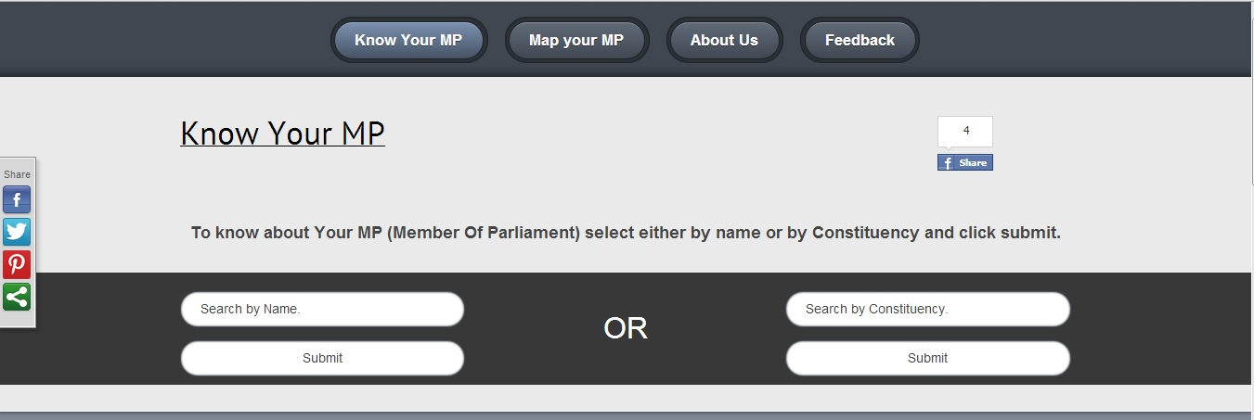

The user needs to select either the Name of the MP or by the name of the Constituency and click submit. The system will return back data of personal details and the Attendance status of respective search.

3.1.2 Hardware Interface:
The system needs the Standard minimum requirements as per the Hardware is concerned.

3.1.3 Software Interface:

The system interfaces with database (phpmyadmin), Apache server and also with jquery and jscript libraries.

3.1.4 Communication Interface:

System asks only to enter the name of the MP or the name of the constituency.
It queries the input and show the result on the screen.

3.2 Functional Requirements:

3.2.1 Input:

The user just needs to enter either the Name of the MP or name of the Constituency which he/she is looking for.
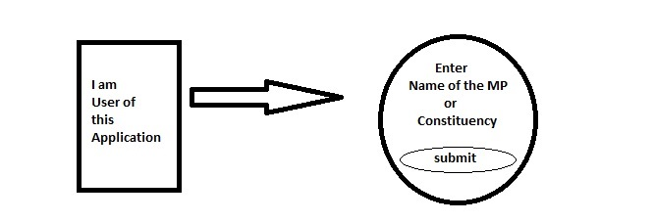

3.2.2 Processing:

The underlying program fetches the information (Personal details and the Attendance status) according to the input from the user and displays it on the screen.

3.2.3 Output:
The system gives the Personal details nad the status of the Attendance in the parliament for the selected MP.

Where Map view provides personal details of the selected constituency only.

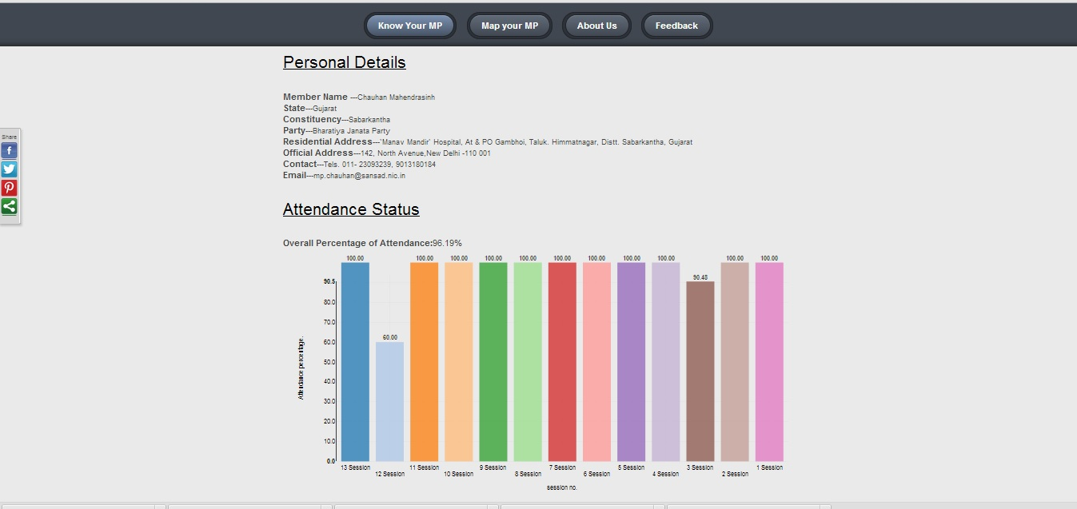

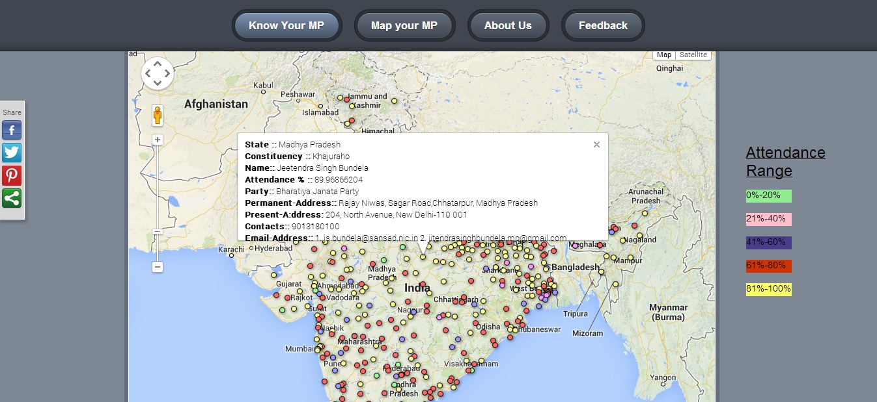
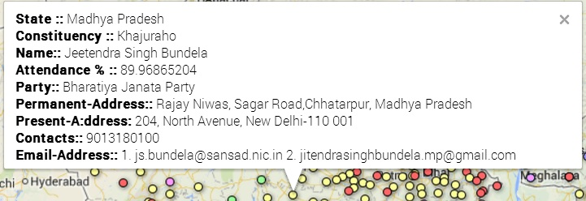

3.2.4 Error handling:

The system handles the errors such that if the user enters incorrect Name or Incorrect Constituency then following error appears.
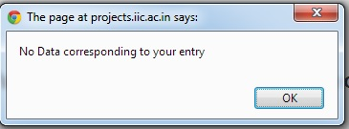

Another error when User hit submit without enterin any field , then system replies with “ No Data Entered”

3.3 Use case:

3.3.1 User Use case:

Step by Step Description:

• Land to Home page.
• Select either Name of the MP or Constituency.
• Submit the querry.
• Get the result page with all details of selected MP or Constituency.
• Can view data on the map by selcting the Constituency.

3.3.2 Author/Editor Use case:

Step by Step description:
• Author has all rights to commit changes.
• Can view and edit the source code.
• Update info, check status, update pictures.

3.4 Non Functional Requirements

3.4.1 Performance:

The system performs well on Chrome, Mozilla and safari. It also needs internet connectivity with good speed.

3.4.2 Reliability:

• The information displayed about each each MP and Costituency is relaible and sourced from government data portal.
• Contact details such as contact no. of the MPs may be in not in the service.

3.4.3 Availability:

The system will be available 24x7. As it will be hosted on Government servers.

3.4.4 Security:

The server on which the system resides will have its own security to prevent unauthorized read/write access. There will be no restriction on downloading the App. There no special protection built in the system other than the author/editor will have the rights to commit changes.

3.4.5 Maintainability:

Author/editor along with mentor and idea person will all be responsible for the maintainence of the system.

3.4.6 Portability:

System is portable upto some extent as it can be accessed from the browser also, so there is no compulsion to have smart phone or android phone.

3.5 Designing Constrains:

The designs, HTML and CSS are not verified with the W3C policies.

3.6 Logical Database Requirements:

The system will run on the Government servers so there is no need to have data base at user end but yes it do require phpmyadmin (database) on the server every time available.

4. Analysis Models

4.1 Sequence Diagrams

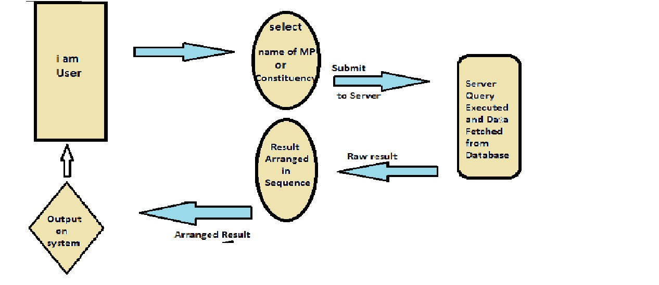

4.2 Data Flow Diagrams (DFD)
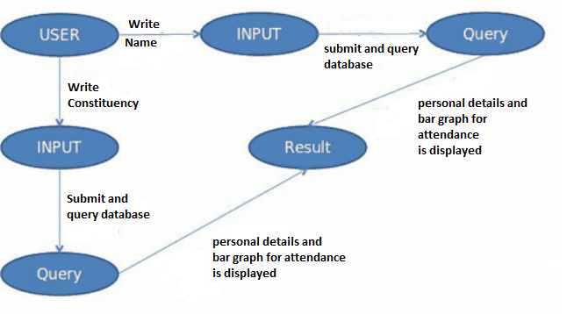

4.3 State-Transition Diagrams (STD)

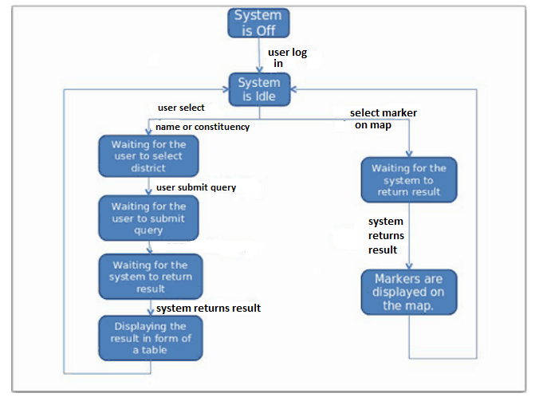
5. Change Management Process:

In order to change management process one has to take permissions from
Institute of Informatics & Communication(IIC) & team Lunatics.

- Appendix

A.1 Conceptual Document:

“Know Your MP”

Vision:
There are many MPs in India by virtue of their selected position.They represent people from their constituency. However, many people might not actually know what their representative is doing in the parliament or the legislative assembly.

Mission:
Main aim of this web Apploication is to create an awareness that people shoold know about their MPs.
So their data has been used in this application to show case their performance in a format that is easily searchable and understood by the user. This data will give people an understanding of how well their representative is functioning in the
parliament. This is crucial in strengthening our democracy by making an informed choice while casting our votes.

Background:
The Parliament of India is the supreme legislative body in India. It was founded in 1921. The Parliament comprises the President of India and the two Houses—Lok Sabha (House of the People) and Rajya Sabha (Council of States). The President has the power to summon and prorogue either House of Parliament or to dissolve Lok Sabha.
India's Parliament is bicameral; Rajya Sabha is the upper house and Lok Sabha is the lower house. The two Houses meet in separate chambers in the Sansad Bhavan .Those elected or nominated (by the President) to either house of Parliament are referred to as Members of Parliament or MPs. The MPs of Lok Sabha are directly elected by the Indian public and the MPs of Rajya Sabha are elected by the members of the State Legislative Assemblies, in accordance with proportional representation. The Parliament is composed of 790 MPs, who serve the largest democratic electorate in the world.
In Lok Sabha the Constitution provides that the maximum strength of the House be 552 members. It has a term of five years.

Solution:
Since election of Lok Sabha members is purely based upon the citizens of India so they play a major role in strengthening Indian politics and this also directly affects the development of the country.
Making people aware of what their representatives are doing in the parliament and how their performance is affecting their own lives, people can optimize their choices during election to elect right representatives during Elections.
This web application Is one small step achieve this goal with the help of data available at http://data.gov.in/catalogs?keys=members&x=-916&y=-237&retain_filters=1&filter=catalog_type%3Acatalog_type_raw_data
“Know Your MP” is developed to facilitate the Indian citizens in order to strengthen the Democracy of India.

Target Group:
Any part of the Indian population who wish to know about their MPs and especially to that part that is eligible to cast their votes.

